Given equation of a circle, it also divides in two spaces where it is used for classification,

Rules for point to be classified is given in below figure.

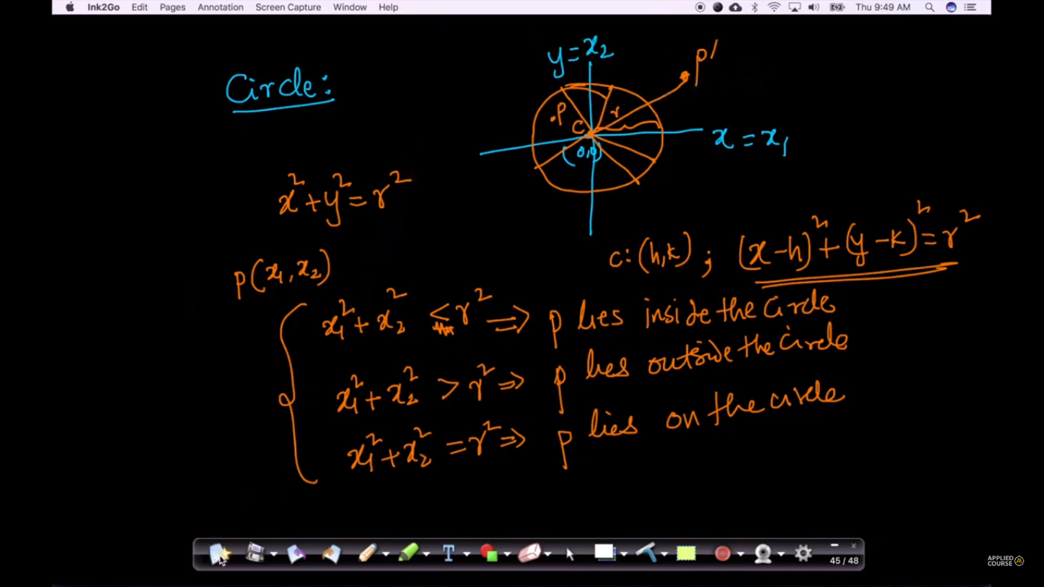

Circle equation can be extended to n-dimensions as given below.

